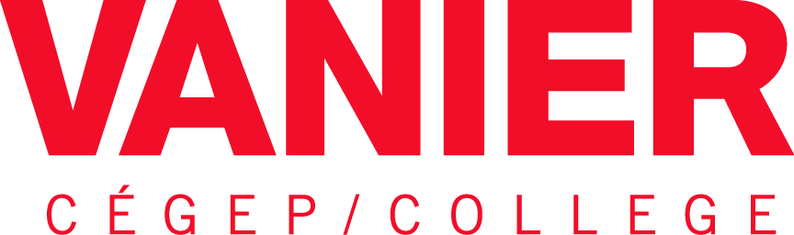

Policy Concerning Management of Hazardous Material

Adopted:

Effective:

Article 1

Purpose

  - Ensure a safe and secure environment for all persons present on College premises.

  - Prevent and limit the negative impact from an incident on persons, property and the environment.

  - To conform to the legislation inherent to hazardous material.

Article 2
Definitions
2.01 In this Policy, unless otherwise indicated, the following words, terms and expressions mean:
a) College: Vanier College
b) College Premises: Any property that is either owned by the College or used by the College.
c) Hazardous Material: A substance which because of its characteristics may pose an actual or potential hazard to humans or to the environment when improperly treated, stored, transported, used, disposed of, or otherwise managed.
d) Accident: An industrial accident as meant in of the Act respecting industrial accidents and occupational diseases.
e) Incident: A sudden and unforeseen event that may cause property damage or bodily harm.
f) Dangerous situation: A situation which may represent a risk of accident or incident.
g) Association: Union, foundation or association recognized by the College and working on college premises.
h) Company: Any physical or moral person working on college premises by virtue of a contractual agreement.
i) Storage Site: Areas where hazardous materials are stored.
j) WHMIS: Workplace Hazardous Material Information System, including Globally Harmonized System requirements as of February 2015
k) SDS: Material Safety Data Sheet
Article 3
Scope

3.01 This Policy applies to any employee, student, visitor or contractor that works with, uses or manipulates a hazardous material on college premises.

Article 4
Policy Statements

4.01 Vanier College (“the College”) is committed to ensuring hazardous materials present on college premises are managed responsibly and in a prevention perspective.

As such, clear procedures related to the purchase, reception, storage, use, transport and disposal of hazardous materials shall be developed, maintained and made accessible to all individuals who may be in contact with hazardous materials while on College premises.

4.02 The College encourages employees, students and contractors to use the least hazardous chemical option available and to minimize their use of hazardous substances whenever appropriate.

It also supports the development and utilization of cost-effective and environmentally responsible pollution prevention and waste reduction technologies or methods.

4.03 While on College premises, hazardous materials are to be kept in appropriate storage, transportation, use and disposal conditions at all times, in order to limit risks associated with their presence on site. This includes limiting the quantities of stocked materials to a maximum of 1-year supply and properly disposing of expired substances or substances identified as excess material without future need.

4.04 Hazardous materials are to be manipulated only by employees, students and contractors who have received adequate training on how to minimize risks to self, others and the environment. Training must be renewed on a 3-year basis.

4.05 Hazardous materials safety training is to be included in academic curriculum whenever students are expected to be in contact with hazardous materials during the academic year or as a result of their graduation in a given program.

Article 5
Roles and Responsibilities

5.01 Rights and obligations of the College
- The College reserves the rights to:
  - Adopt any regulations or guidelines deemed necessary to the application of the policy.
  - To take any appropriate measure to ensure that the policy and all deriving regulations, processes and guidelines are respected.
- The obligations of the College:
  - Ensure that hazardous material inventories are taken.
  - Ensure the safe storage of hazardous material.
  - Ensure proper emergency and spill control procedures are available and regularly reviewed.
  - Ensure that all controlled products are labeled in conformity with WHMIS and have a Safety Data Sheet.
  - Ensure the availability of all Safety Data Sheets to all personnel.
  - Ensure the safe disposal of hazardous material.
  - Ensure training of personnel on WHMIS, labeling requirements, Safety Data Sheets, safe work procedures and emergency protocols.
  - Ensure the availability of necessary personal protection equipment.
  - Ensure the respect of regulations and guidelines derived from the policy.

5.02 Rights and obligations of employees and students
- Rights:
  - To have a safe working and learning environment.
  - To be informed, trained and advised of all risks that are inherent to their use of hazardous materials.
  - To have access to personal protection equipment required to ensure their health and safety.
  - To refuse to accomplish a task that, in undue manner, would present a risk to their health and safety or that would have the effect of exposing a third party to a similar risk.

- Obligations:
  - To respect the policy and all associated regulations and guidelines
  - To take the necessary actions to ensure their health and safety.
  - See that they do not endanger the health, safety or physical well-being of other persons at or near their working or learning area.
  - Participate and collaborate actively in the identification and elimination of the risk of accidents or occupational diseases within the College.

5.03 Rights and obligations of associations and other organizations
- Rights:
  - The College recognizes the rights and obligations conferred by law to all associations or organizations present on college premises.
- Obligations:
  - To respect the present policy and its supporting regulations, procedures and guidelines.
  - Take the necessary measures to preserve the health and safety of all persons present on College premises, as well as to ensure the integrity of College property and environment.

Article 6
Authority
6.01 Management of hazardous material is under the authority of the Manager of Safety & Security Services

Article 7
Responsibility for the application of the policy
7.01 The application of this policy is under the responsibility of every faculty, department or service in which employees are working with or handling hazardous materials.

Article 8
Effective Date
8.01 This policy will become effective upon adoption by the Vanier College Board of Directors.

