Name: __________________________________ Student Number: ______________________

Part A: Multiple Choice

Questions 1-2: Use the following diagrams to answer questions 1-2.

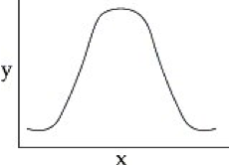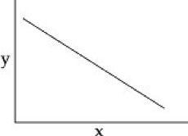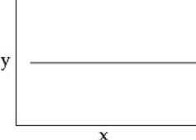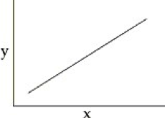
B
A
C
D

1. You make a phospholipid bilayer with short, saturated hydrocarbon tails. You measure the permeability of this membrane to oxygen. You then double the length of the hydrocarbon tails, and remeasure membrane permeability. You then double the length of the hydrocarbon tails again, and make a third measurement of membrane permeability. You graph membrane permeability as a function of hydrocarbon tail length. Which of the graphs below best represents the data you expect?

2. You make a phospholipid bilayer with short, saturated hydrocarbon tails. You measure the permeability of this membrane to oxygen. You are going to change the length of the hydrocarbon tails and remeasure membrane permeability, but first your boss asks you to graph the data you expect if there is no effect of hydrocarbon tail length on membrane permeability (your null hypothesis). Which of the graphs below best represents the data you expect if your null hypothesis is correct?

3. What preserves the structural integrity of phospholipid bilayers?
A. hydrophobic and hydrophilic interactions between nearby phospholipids
B. van der Waals interactions between the glycerol molecule and fatty acids of a single phospholipid
C. sugars associated with the cell membrane covalently cross-link
D. peptide bonds form between the phosphate groups of the phospholipids

4. Which of the following crosses lipid bilayers the fastest?
A. a small, polar molecule like water
B. a sodium ion
C. a small, nonpolar molecule like oxygen (O₂)
D. a large, polar molecule like glucose

5. You have just discovered an organism that lives in extremely cold environments. Which of the following would you predict to be true about the phospholipids in its membranes, compared to phospholipids in the membranes of organisms that live in warmer environments?
A. The membrane phospholipids of cold-adapted organisms will have more saturated hydrocarbon tails.
B. The membrane phospholipids of cold-adapted organisms will have longer hydrocarbon tails.
C. The membrane phospholipids of cold-adapted organisms will have more unsaturated hydrocarbon tails.

6. You place yeast cells in a glucose solution and plot the rate of glucose uptake. You see an increase in glucose uptake over time (that is, the longer the yeast are in the sugar solution, the faster they can take sugar into the cell). The most likely explanation for this is the cell membrane is becoming more permeable because
A. the difference in glucose concentration between the inside of the cell and the outside of the cell is increasing.
B. the yeast is inserting more glucose transporters into its membrane.
C. the yeast is inserting more cholestrerol into the membrane.
D. the difference in glucose concentration between the inside of the cell and outside of the cell is decreasing.

7. What is the most important factor in explaining why osmosis occurs spontaneously?
A. The process is endothermic
B. The process is exothermic
C. It leads to an increase in entropy.
D. It leads to a decrease in entropy.

8. Which statement best describes the electrochemical gradient for chloride ions in the figure, assuming the chloride concentrations are equal on both sides of the membrane?
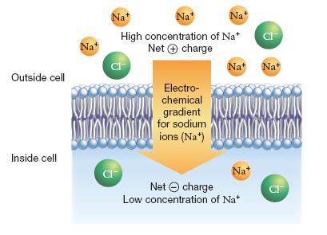

A. There is no electrochemical gradient for chloride ions.
B. It favours the movement of chloride ions from the outside to the inside of the cell.
C. It favours the movement of chloride ions from the inside to the outside of the cell.
D. It favours movement of chloride ions in both directions across the membrane.

9. Under otherwise equivalent conditions, do more chemical reactions occur with a catalyst than without one? Why or why not?
A. Yes. Because catalysts lower the free energy (G) of the products, the reaction is more likely to be spontaneous.
B. Yes. Because catalysts lower the activation energy, a greater number of reactant molecules will have enough kinetic energy to complete the reaction.
C. No. Catalysts affect only the rate of a reaction, not the number of reactions that occur.
D. No. The number of reactions that occur is determined only by temperature and concentration of reactants, neither of which is affected by a catalyst.

10. In cells, the activity of enzymes is often regulated by other molecules. Why is this necessary?
A. because each enzyme has multiple functions
B. because it is unlikely that all reaction products are required all of the time
C. because all enzymes require some help from another molecule to function correctly
D. because other molecules are necessary to prevent enzymes from denaturing

11. HIV is the virus that causes AIDS. In the mid-1990s, researchers discovered an enzyme in HIV called protease. Once the enzyme's structure was known, researchers began looking for drugs that would fit into the active site and block it. If this strategy for stopping HIV infections were successful, it would be an example of what phenomenon?

A. vaccination
B. competitive inhibition
C. allosteric regulation
D. poisoning

12. Consider the HIV enzyme called protease. The amino acid residues at the active site are highly hydrophobic. In designing a drug that would bind to the active site and jam it, researchers should use which type of molecule?

A. polar
B. acidic
C. hydrophobic
D. charged

13. The lock-and-key analogy for enzymes applies to the
A. specificity of enzyme tertiary subunits joining to form quaternary structure.
B. specificity of enzymes interacting with water.
C. specificity of enzyme primary, secondary, and tertiary structure.
D. specificity of enzymes interacting with ions.
E. specificity of enzymes binding to their substrates.

14. Why does an enzyme alter the activation energy for a reaction but not the overall free-energy change?
A. An enzyme brings reactants together in precise orientations and increases the free energy of the transition state; it does not change the free energies of the reactants or products.
B. An enzyme brings reactants together in precise orientations and increases the free energy of the transition state; it also increases the free energies of reactants and products by an equal amount.
C. An enzyme brings reactants together in precise orientations and reduces the free energy of the transition state; it does not change the free energies of the reactants or products.
D. An enzyme brings reactants together in precise orientations and reduces the free energy of the transition state; it also reduces the free energies of reactants and products by an equal amount.

15. You collect data on the effect of pH on the function of the enzyme catalase in human cells. Which of the following graphs would you expect?
A.  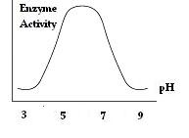 | B.  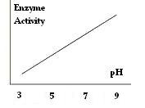
C.  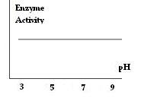 | D.  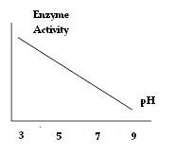

16. Which statement most accurately explains why ATP hydrolysis is highly exergonic?
A. There is a large increase in potential energy because charge repulsion is reduced, accompanied by a large increase in entropy.
B. There is a large drop in potential energy because charge repulsion is reduced, accompanied by a large increase in entropy.
C. ATP contains the carbohydrate ribose, which stores a large amount of chemical energy.
D. Energy is released when a phosphate group is added.

17. In cellular respiration, glucose is _____ and oxygen is _____.

A. phosphorylated, dephosphorylated
B. oxidized, reduced
C. reduced, oxidized
D. produced, degraded

18. A cell has enough available ATP to meet its needs for about 30 seconds. What is likely to happen when an athlete exhausts his or her ATP supply?
A. Other cells take over, and the muscle cells that have used up their ATP cease to function.
B. Catabolic processes are activated that generate more ATP.
C. He or she has to sit down and rest.
D. ATP is transported into the cell from the circulatory system.

19. The high-energy electron carrier that is reduced during glycolysis, pyruvate processing, and the citric acid cycle, and which carries electrons to the electron transport system, is _____.

A. NADH
B. ATP
C. G protein
D. NADPH

20. In the phosphofructokinase molecule shown in the figure below, the active site has a much higher affinity for ATP than the regulatory site does. Which answer best summarizes what the consequences would be if the regulatory site had a much higher affinity for ATP than the active site did?

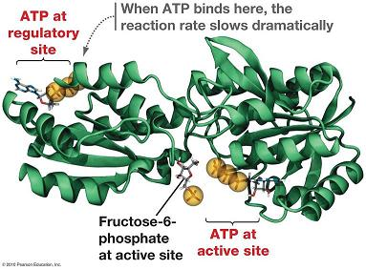

A. Glucose oxidation would be inhibited only at high ATP concentrations.
B Glucose oxidation would be inhibited even if ATP were scarce in the cell.
C. Glucose oxidation would occur faster at low ATP concentrations
D. Glucose oxidation would occur via a completely different metabolic pathway.

21. _____ is the three-carbon sugar that is produced as an end product of glycolysis.

A. Fructose
B. ADP
C. Pyruvate
D. Acetyl CoA

22. Two ATP molecules are expended in the energy investment phase of glycolysis. Why is this energy needed to begin the process of glucose catabolism?
A. It is needed to induce the enzymes of glycolysis.
B. It is needed because glycolysis is considered an exergonic process which always requires input of energy from ATP.
C. Some energy must be invested to make the glucose molecule unstable and begin the process of catabolism.
D. It is needed to generate the electron carrier NAD⁺.

23. In the energy-yielding phase of glycolysis, energy is extracted in the form of _____.

A. ATP
B. ATP and NADH
C. NADH
D. pyruvate

24. A substrate-level phosphorylation occurs in the Krebs cycle (also known as the Citric Acid Cycle) when _____

A. acetylation of oxaloacetate takes place
B. NAD⁺ is phosphorylated to NADH
C. GDP is phosphorylated to produce GTP
D. oxaloacetate is phosphorylated

25. For the oxidation of pyruvate shown in the figure below, which answer correctly identifies molecules involved in the positive (+) and negative (-) control of this reaction?
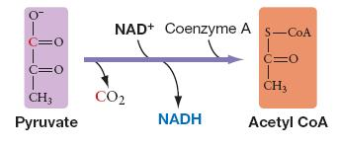
A. | +: NADH, CoA, ATP; | -: acetyl CoA, NAD⁺, AMP
B. | +: NAD⁺, CoA, ATP; | -: acetyl CoA, NADH, AMP
C. | +: NAD⁺, acetyl CoA, AMP; | -:CoA, NADH, ATP
D. | +: NAD⁺, CoA, AMP; | -: acetyl CoA, NADH, ATP

26. The reactions of pyruvate processing, the citric acid cycle, and the electron transport chain occur within the _____ in the cell.

A. mitochondria
B. cytoplasm
C. chloroplast
D. nucleus

27. The first CO₂ that is released during aerobic cellular respiration is _____.
A. during the citric acid cycle
B. during glycolysis
C. just after the citric acid cycle
D. between glycolysis and the citric acid cycle

28. Which of the following statements about cellular metabolism is FALSE?
A. Citric acid cycle activity is dependent solely on availability of substrate; otherwise it is unregulated.
B. Reactions of the Krebs cycle take place in the mitochondrial matrix.
C. In the electron transport chain, electrons decrease in energy level as they are transferred from one electron carrier to the next.
D. Glycolysis is inhibited when cellular energy levels are abundant.

29. Why is ATP production during cellular respiration characterized as indirect?
A. ATP is not produced directly by the ETC but instead via the proton gradient generated during electron transport through the ETC.
B. Electrons are not passed directly from NADH and FADH₂ to O₂ but indirectly through the ETC.
C. ATP is produced by enzymes indirectly associated with the ETC that perform substrate-level phosphorylation.
D. Most of the ATP is produced during glucose oxidation, which occurs through a series of intermediate steps.

30. Which of the following events takes place in the electron transport chain?
A. the extraction of energy from high-energy electrons remaining from glycolysis and the citric acid cycle
B. the breakdown of an acetyl group to carbon dioxide
C. breakdown of glucose into two pyruvate molecules
D. substrate-level phosphorylation

31. Which answer best explains why organisms that have an ETC as well as fermentation pathways almost never ferment pyruvate if the electron acceptor required by the ETC is available?
A. The molecule formed by addition of an electron to pyruvate is toxic to the cell.
B. Fermentation is extremely inefficient because it is so slow.
C. Fermentation is extremely inefficient in terms of the number of ATP molecules produced for each molecule of glucose metabolized.
D. The ETC outcompetes fermentation pathways for use of the electron acceptor.

32. The inner mitochondrial membrane normally _____.
A. contains enzymes responsible for two of the chemical reactions that take place as part of glycolysis
B. contains permease channels that allow small ions and water to pass readily through the membrane by simple diffusion
C. contains an active transport pump that pumps protons into the inner mitochondrial compartment from the point of high concentration to a point of lower concentration
D. is virtually impermeable to hydrogen ions (protons)

33. During photosynthesis, the light energy from the Sun is captured and stored in the bonds of _____.

A. glucose
B. hemoglobin
C. water
D. oxygen

34. Why does a leaf appear green when a person looks at it?
A. The chlorophyll pigments reflect all wavelengths of light except in the green spectrum, which it absorbs.
B. Only the green wavelengths of light from the Sun reach the Earth.
C. The chlorophyll pigments are colored green.
D. The chlorophyll pigments absorb all wavelengths of light except in the green spectrum, which it reflects.

35. The absorption spectrum of a plant shows what wavelengths of light the plant absorbs. The absorption spectrum depends on _____.
A. the wavelengths of light to which the plant’s pigments respond
B. the wavelengths of light that hit the plant
C. the wavelengths of light that are transmitted by the plant
D. the surface area of the leaf

36. Which statement is most accurate concerning how photosystem II (PS II) compares to the electron transport chain (ETC) of mitochondria?
A. In both systems, ATP is produced by chemiosmosis.
B. The ETC associated with PS II shares no similar components with the ETC of mitochondria
C. In both systems, high-energy electrons com from NADH.
D. PS II produces ATP by chemiosmosis; the ETC of mitochondria produces ATP by substrate-level phosphorylation.

37. As electrons are passed through the system of electron carriers associated with photosystem II, they lose energy. What happens to this energy?
A. It excites electrons of the reaction center of PS I.
B. It is lost as heat.
C. It is used to phosphorylate NAD+ to NADPH, the molecule that accepts electrons from PS I.
D. It is used to establish and maintain a proton gradient.

38. Plastoquinone (PQ), an electron carrier of small molecular weight, is found in the electron transport chain associated with photosystem II. If PQ is not directly anchored to other membrane or cytoplasmic structures, it is probably _____.
A. mobile in the thylakoid membrane
B. lipid soluble
D. a molecule that serves as a shuttle between the electron transport chain and ATP synthase
D. Both A and B are correct.

39. During the Calvin cycle, carbon dioxide is _____, in order to drive the formation of sugars.

A. destroyed
B. produced
C. oxidized
D. reduced

40. Which statement is correct regarding how CO₂ is delivered to rubisco in C₃, C₄, or CAM plants?
A. In C₄ plants, CO₂ is delivered via 4-carbon organic acids.
B. In C₃ plants, CO₂ is first stockpiled in cells where rubisco is inactive.
C. In C₃ plants, CO₂ is delivered via 3-carbon organic acids.
D. In CAM plants, CO₂ is first stockpiled in cells where rubisco is inactive.

41. What is the main purpose of the light-dependent reactions of photosynthesis?

A. to generate oxygen by "splitting" H₂O
B. to produce NADPH for use in respiration
C. to use ATP to make glucose
D. to produce NADPH and ATP

42. In the carbon fixation step of the Calvin cycle, ribulose-1,5-bisphosphate (a five-carbon compound) is carboxylated to produce _____.

A. 5 molecules of carbon dioxide
B. 2 three-carbon compounds
C. acetyl CoA (two carbons) and oxaloacetate (four carbons)
D. glucose

43. Which of the following statements most accurately compares photosynthesis and respiration?
A. ATP generated during photosynthesis is a fundamentally different process than ATP generated during respiration.
B. Photosynthesis stores energy in complex organic molecules; respiration releases the energy stored in complex organic molecules.
C. Photosynthesis requires ATP, but respiration does not.
D. Photosynthesis is just respiration in reverse.

44. Most of the enzymes of the Calvin cycle also function in other metabolic pathways. This should not be a surprising finding, because _____.
A. metabolic reactions are catalyzed by enzymes that have multiple functions
B. the Calvin cycle is nearly ubiquitous in cells, as are metabolic pathways
C. the Calvin cycle probably evolved at the same time as did glycolysis
D. there is a close relationship between carbohydrate synthesis and carbohydrate metabolism

45. How are the light-dependent and light-independent reactions of photosynthesis related?
A. The products of light-independent reactions must be present for light-dependent reactions to take place.
B. The products of light-dependent reactions are used in light-independent reactions.
C. The products of the light-independent reactions are used in the light-dependent reactions.
D. They are not related.

Part B: Short Answer

- Why can the rate of photosynthesis be estimated by measuring the rate of oxygen production in chloroplasts? (2 marks)
- What would happen in a chloroplast containing an unusual form of rubisco that did not bind oxygen? (1 mark)
- Explain the difference between PS I and PS II. (3 marks)
- What does it mean to “uncouple” proton diffusion from ATP production? (2 marks)
  - Why does this phenomenon occur? (1 mark)
- What job does the electron transport chain accomplish in order to drive the formation of ATP? (2 marks)
- Why do enzyme-catalyzed reactions reach a saturation level when substrate concentration is increased? (1 mark)
- What will happen to a red blood cell (RBC), which has an internal osmotic pressure equal to that of 0.9 % NaCl solution, if it is placed into a beaker of pure water? Explain your answer. (2 marks)
- Where would you most likely find an integral membrane protein? (1 mark)
- Why is facilitate diffusion considered passive transport? (1 mark)

